MSE1: Cloud Foundations (AI103E)

Lab Exercise 2: Host a Static Website on Amazon S3.
Instructions:
- Create Bucket name should be: s3-yourfirstname-rollnumber
- Hosted webpage should have
  - <h1>AWS S3 Static Website</h1>
  - <p>Name: Your Name</p>
  - <p>Roll Number: Your Roll Number</p>
- Submit the following in a word file:
  - Screenshot of S3 bucket.
  - Screenshot of hosted webpage opened in browser with s3 website URL.
  - S3 Website URL.
Note: Do not delete or stop the hosted S3 bucket till 9 PM today.

Solution:

- Screenshot of S3 bucket with bucket name
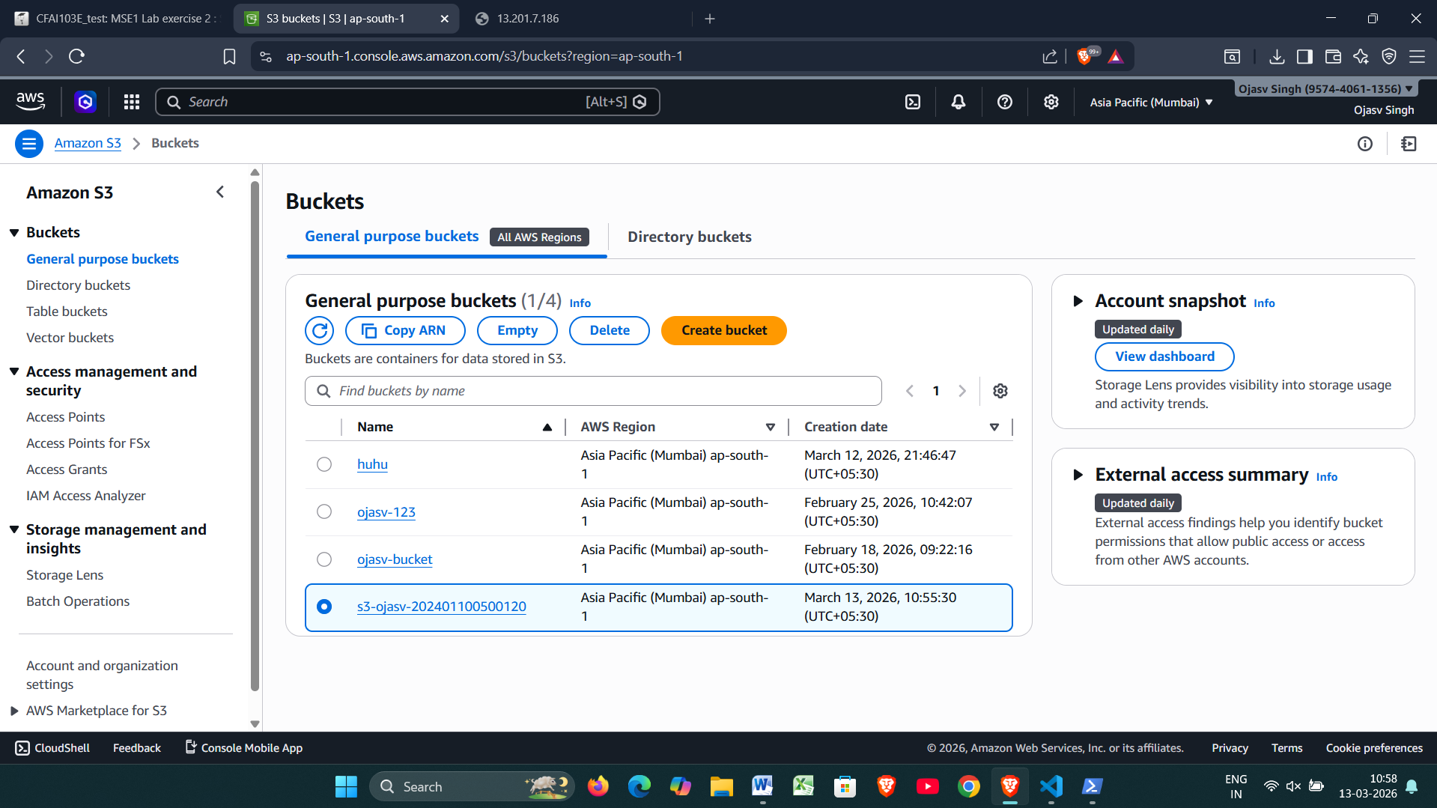

- Screenshot of webpage opened in browser with S3 bucket URL & clear content as described in instructions.
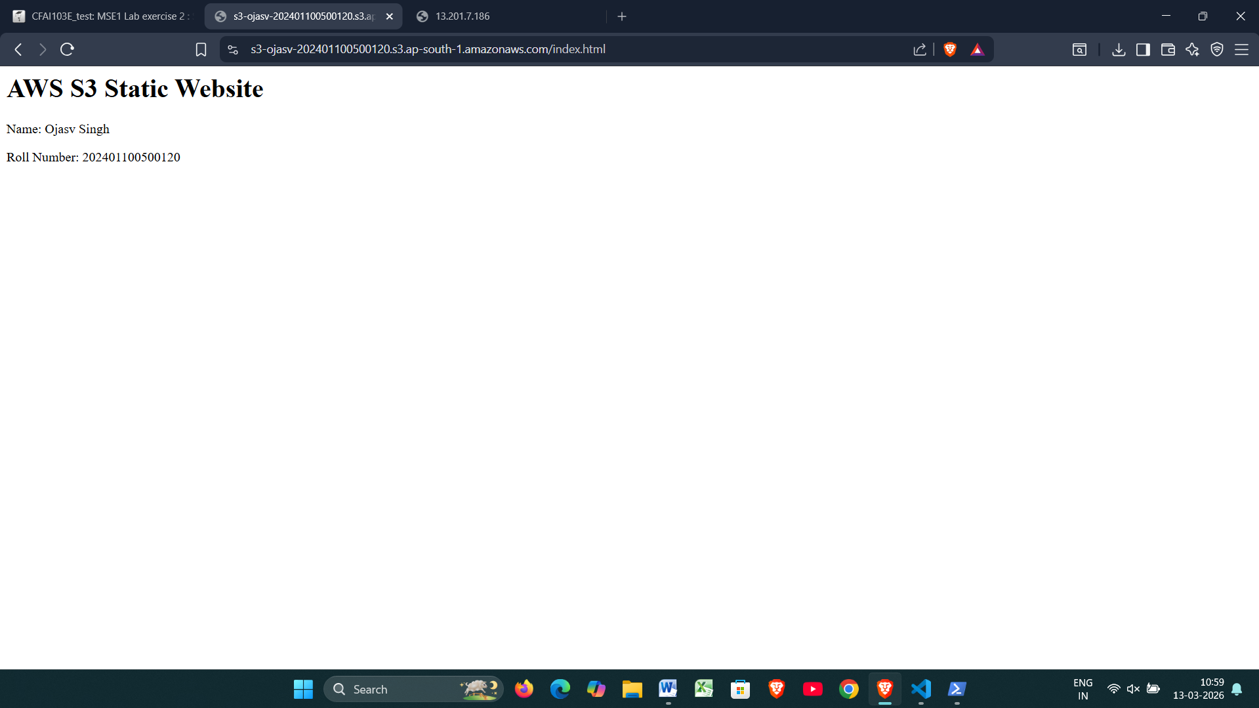
- S3 Website URL
https://s3-ojasv-202401100500120.s3.ap-south-1.amazonaws.com/index.html

